Galaxy MySQL database

Date: 23 Jan 2007

1 Introduction 2
1.1 Minimum hardware configuration 2
1.2 Recommended Hardware Configuration 2
1.3 Master-slave: Replication & backup 2
1.3.1 On the master server 3
1.3.2 On the slave server 4
2 Installation of MySql Server version 5.0 5
2.1 MySQL Download 5
2.2 MySQL Installation 6
2.3 MySQL Server configuration 10
2.3.1 Case 1: Standard configuration 11
2.3.2 Case 2: Detailed configuration 13
2.4 Verification and possible problems 19
2.4.1 Verification 19
2.4.2 Possible problems 19
3 GexDB installation 21
3.1 Master server / Single server installation 21
3.2 Slave server installation 24

Introduction

Minimum hardware configuration

For acceptable performances, the Galaxy server holding and managing the MySql database should at least be the following:

Computer type | PC
OS | Windows XP
Processor speed | 2 GHertz
RAM | 1 Gb
Hard disk | 100 Gb

Recommended Hardware Configuration

We recommend the following configuration for the Galaxy server holding and managing the MySql database:

Computer type | PC
OS | Windows XP
Processor speed | 3 GHertz single-core OR  2 GHertz dual-core
RAM | 2 Gb
Hard disk | 250 Gb

Master-slave: Replication & backup

How to have a main server (master) and backup server (slave) in perfect sync.

 | MASTER |  | SLAVE |  | ARCHIVES
 | GexDB |  | GexDB (replication thru server bin-logs) |  | Dump.ZIP
 | Bin-logs (for replication & incremental backup) |  |  |  | Bin-logs.ZIP
 | Purge samples/summaries/entries with tables locked
 | Incremental backup - zip and delete bin-logs files
 | Full Backup - dump the GexDB (server on hold)
 | Check & Repair

On the master server

The galaxy database (GexDB) to which Examinator allows to run queries and analyze datasets is in read & write mode. The database receives all data files (mostly STDF), daily.

Each database modification issues a new line in the current bin-log file. This bin-log holds all insertions / modifications made to the database. This file is read by the slave server (so remains in sync. The bin-log files are only erased on the master server after the slave server has made its updates.

Purges are only made on the main server ( only database accepting ‘delete’ queries).

Backups (incremental or Full) are executed on the main server as it is the server always holding the most recent information (while backup server may be slightly out of sync).

The ‘check & repair’ should be done once a week (at night for minimum impact). The average execution time of this task is about 300 Mb / minute.

Scheduled tasks on the master server include :

- Database purge
- Database incremental backups (bin-logs files)
- Database full backup to a archive server or media
- Check & Repair of mySQL database

The purge task

The purge task is called once a week and consists of the following three steps:
Purge step | Database info purged
purge samples older than 30 days | result + run
purge summaries older than 180 days | Above &  + test_info + test_limits + stats_summary_test  + stats_samples_test + stats_summary_bin  + stats_samples_bin + bin
purge split-lot entries older than 360 days | Above &  + stats_summary_parts + stats_samples_parts + splitlot

The backup task

The incremental backup tasks (also performing bin-logs cleanup) is called once a week (day of the week user-configurable in the gexdb_mysql_install.ini file)
To keep the bin-log files size low, the option max_binlog_size can be customized. The default value is 4Gb meaning each bin-log file can be up to 4Gb. If the size exceeds this limit, then the file is closed and a new one (with the extension incremented) is created. A each server boot the current bin-log is closed and a new one generated (eg: if you reboot 4 times the server the same week, you would find 4 different bin-logs).

All bin-logs (except the one currently in use) are kept in compressed format. Using the appropriate mySQL query, one can know which bin-log is currently in use.

All bin-logs with a date older than the last backup date are ignored in new backup sequences. Such bin-logs can be archived or erased to save disk space.

The full backup task is executed once per month (user configurable in gexdb_mysql_install.ini) and does the following :

- Task first locks tables in READ mode so no further insertion can take place while performing the backup
- Bin-logs on the master server are compressed and copied to the archive server
- A dump of the full database is performed, then compressed and copied to a new folder in the backup server
- Tales are unlocked (back to READ+WRITE)
- Bin-logs no longer required for replication are erased

The Check & Repair task

This task is called once per week (user configurable in gexdb_mysql_install.ini)

On the slave server

The database (replicated from the master server) is in READ only mode for users. It can’t be modified (to avoid breaking the sync mechanism). IT receives synchronization events daily (thru bin-log files)
This database can be accessed for READ only missions: Examinator data analysis, queries, build STDF files from queries, etc…

Installation of MySql Server version 5.0

MySQL Download

Download the latest 5.0 official release of MySQL at:

http://dev.mysql.com/downloads/mysql/5.0.html#downloads

Go to paragraph ‘MySQL 5.0 Community Server - Generally Available (GA) Release’

And download the following package:
Windows downloads (platform notes)
Windows Essentials (x86) |  | 5.0.27 | 16.8M | Download | Pick a mirror
MD5: 4b6ffcaae7e71e24646c4e02324450ce | Signature

Extract file Setup.exe from file mysql-5.0.27-win32.zip into a temporary folder.

MySQL Installation

Perform the MySQL installation on the master server (if no slave server wanted), or on both servers (master server first, then slave server last).

Launch the setup.exe installation program, and follow instructions as detailed hereafter:

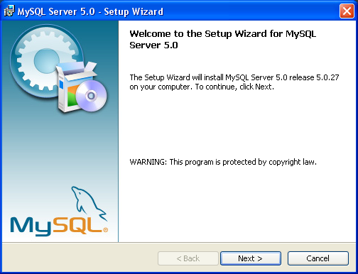
Click the ‘Next’ button

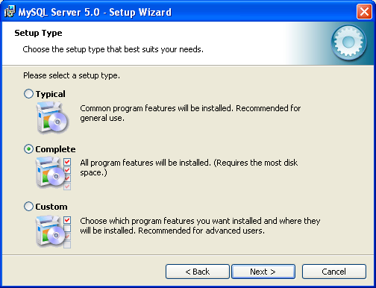
Select ‘Complete’ installation mode, and click the ‘Next’ button.

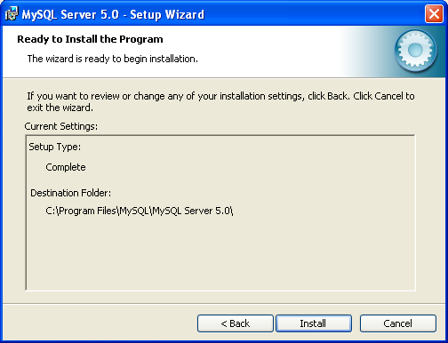
Install into the default folder ‘C:\Program Files\MySql\MySQL Server 5.0\’
You can select a different folder if this makes sense to you.
Then, click the ‘Install’ button.

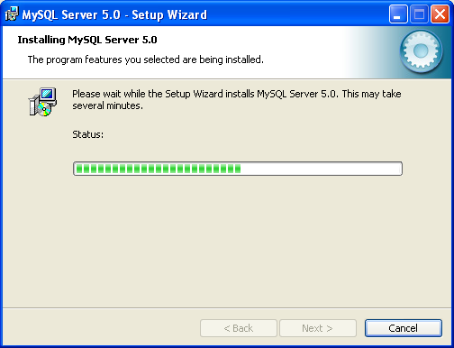

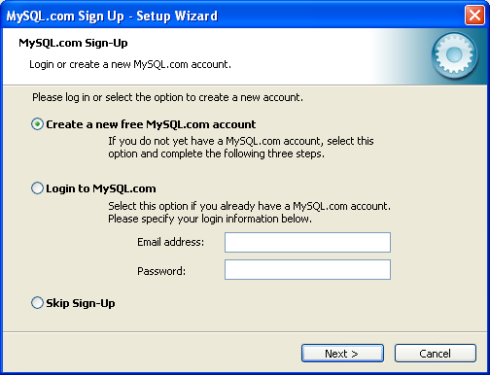
Register yourself to the user community if you want to.

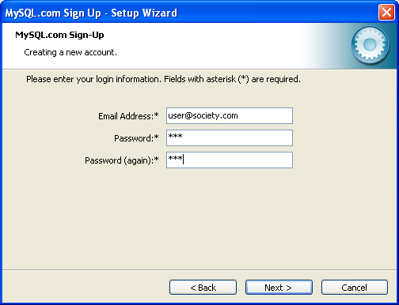

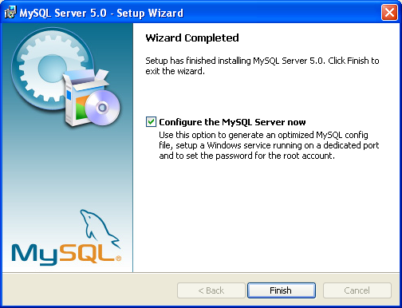

The installation of the MySQL server is now done!

The next step is to setup the MySQL server, which can be done either by checking the ‘Configure the MySQL Server now’ button before clicking the ‘Finish’ button, or at a later time by using the link:

‘Windows Start menu->Programs->MySQL->MySQL Server 5.0->MySQL Server Instance Config Wizard’

MySQL Server configuration

Unless the MySQL Server Instance configuration wizard automatically starts because you clicked the ‘Configure the MySQL Server now’ check box at the end of the installation process, launch it using the following Windows link:

‘Windows Start menu->Programs->MySQL->MySQL Server 5.0->MySQL Server Instance Config Wizard’

The following configuration wizard will enable you to configure your MySQL server instance (options, root password), and install it as a Windows service.

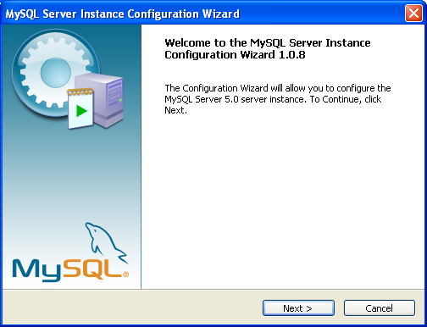
Click the ‘Next’ button

Case 1: Standard configuration

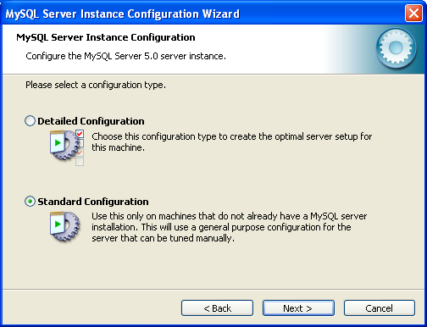
Select ‘Standard Configuration’, and click the ‘Next’ button

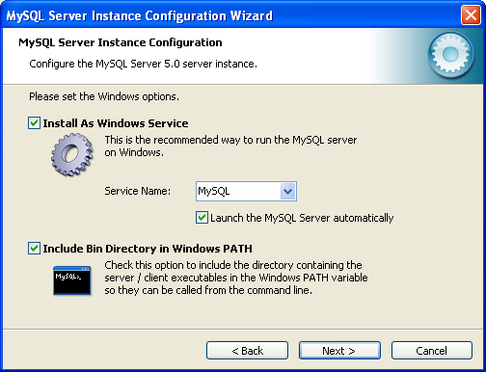
Select the options as shown in the above snapshot and click the ‘Next’ button.

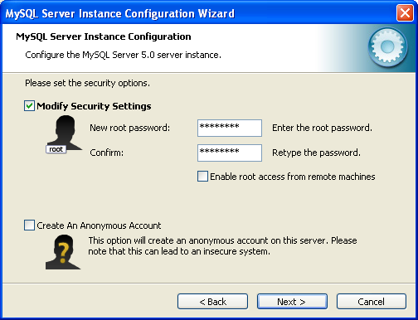
Enter the root password of your choice, and click the ‘Next’ button

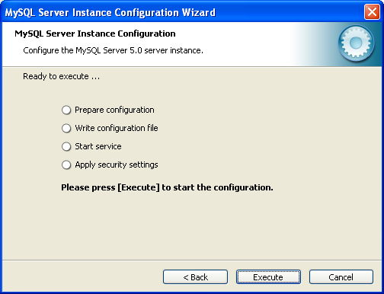
Click the ‘Execute’ button
If the error 2003 is thrown, click the ‘Retry’ button.

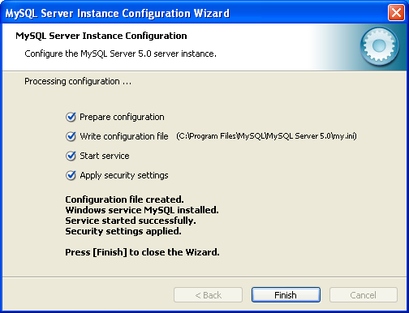
The configuration is completed, click the ‘Finish’ button.

Case 2: Detailed configuration

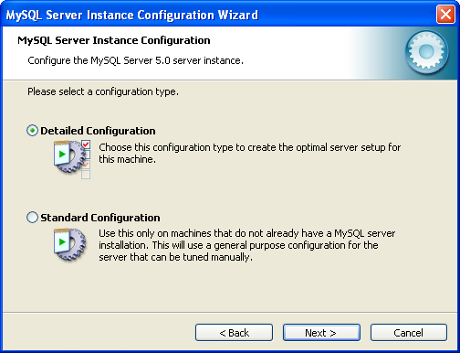
Select ‘Detailed Configuration’, and click the ‘Next’ button

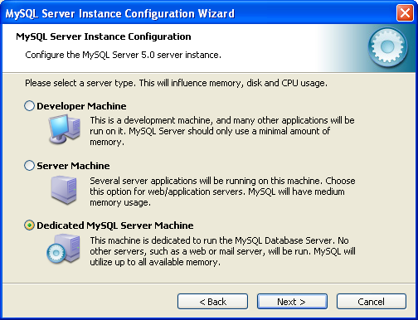
Select the ‘Dedicated MySQL Server Machine’ option, unless you are installing MySQL on a server that will run other CPU and memory intensive applications, in which case you should select the ‘Server Machine’ option. Then click the ‘Next’ button.

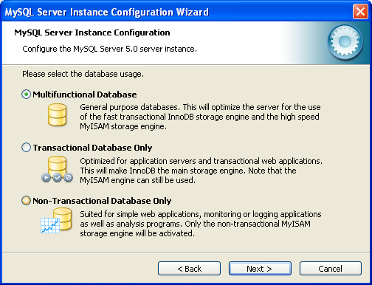
For database size and efficiency, the Galaxy SQL database (GexDB) uses the MyISAM storage engine. We recommend to select the ‘Multifunctional Database’ option, rather than the ‘Non-Transactional Database Only’ option, so that other databases may use the InnoDB storage engine if need be. Click the ‘Next’ button.

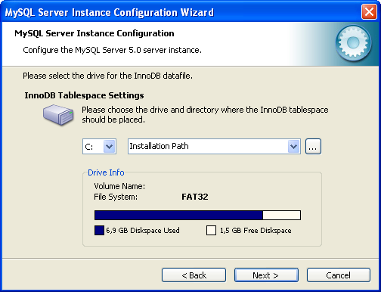
Let the software create the database installation folder for you. If you want a custom database folder to be used, make the appropriate selection and be sure to check the configuration file my.ini to check the custom folder is correctly saved. Click the ‘Next’ button.

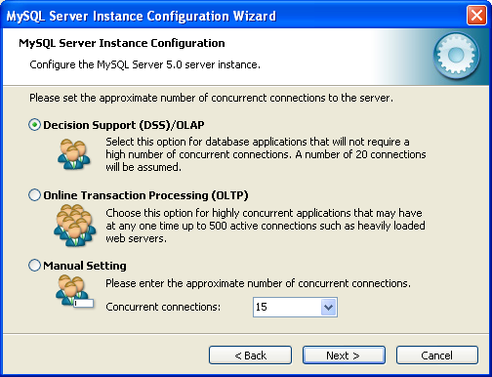
Select the most appropriate option, and click the ‘Next’ button.

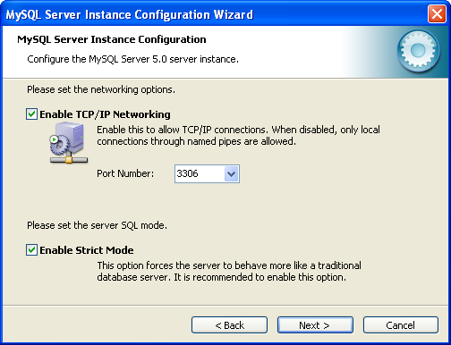
Check the ‘Enable TCP/IP Networking’ check box, and leave the default ‘Port Number’, unless it is already used by another service on your server. Click the ‘Next’ button.

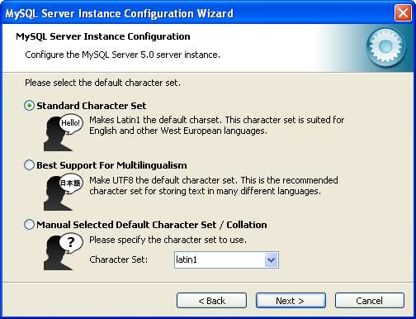
Keep the default selection, click the ‘Next’ button.

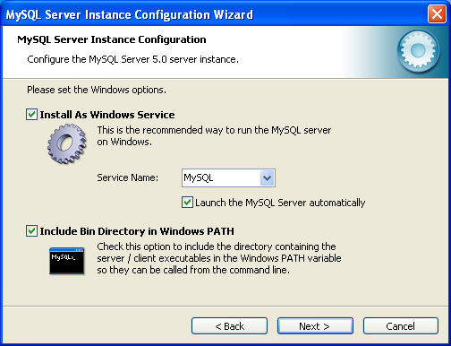

Select the options as shown in the above snapshot and click the ‘Next’ button.

Enter the root password.
Enable root access from remote machines only if necessary.
Click the ‘Next’ button.

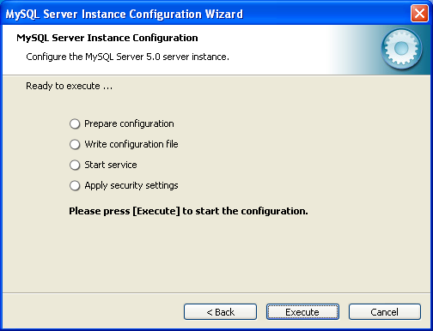
Click the ‘Execute’ button

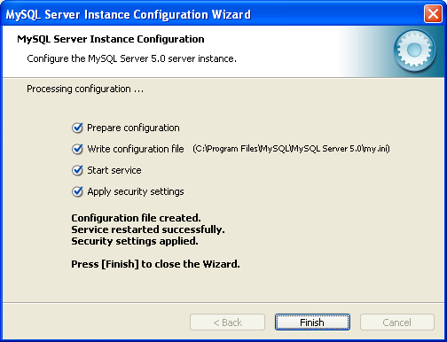
The configuration is completed, click the ‘Finish’ button.

Verification and possible problems

Verification

To make sure the MySQL Server service started as expected, launch the Windows Services control panel:
‘Windows Control Panel->Administrative Tools->Services’

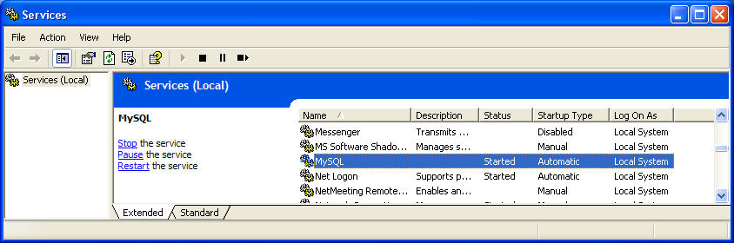
Make sure you see the ‘MySQL’ service in the list, and that the ‘Status’ column says ‘Started’.

Possible problems

The installation may fail on trying to start the service. If so, click the ‘Back’ button to start again the service. If the service still doesn’t start, the my.ini file may be incorrect or corrupted (eg: datadir entry missing, or invalid option).

Error 1045 or Error 106 :

Check the access paths specified in the my.ini file:
#Path to installation directory. All paths are usually resolved relative to this.
basedir="C:/Program Files/MySQL/MySQL Server 5.0/"
#Path to the database root
datadir="C:/Program Files/MySQL/MySQL Server 5.0/Data/"
Check user names & passwords

Error 2003

Under the ‘MySQL Server Instance Config Wizard‘, the error 2003 may be seen while executing the ‘Apply Security Settings’. Start over this step usually fixes the problem.

Fail starting SQL server at first launch

Check your firewall settings (it may bloc the socket port used).

Manually start and stop the server

To manually start the MySQL Server service, open a command window and type command ‘net start mysql’
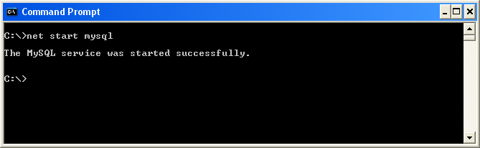

To stop the MySQL Server service, type command ‘net stop mysql‘
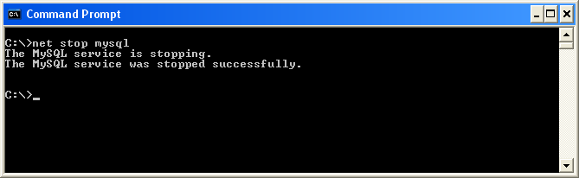

GexDB installation

The GexDB database can be installed either on a single master server, or if you want to activate the replication mechanism, on a master server, and then on a slave server.

Master server / Single server installation

- Copy all files from the directory <Examinator installation path>/mysql/install to the directory <MySQL installation path>/bin.
- Edit the file <MySQL installation path>/bin/gexdb_mysql_install.ini
This file contains most configuration options for the GexDB database.
We assume the <master-host> designates the master server and <slave-host> the slave server
When performing the setup of the master server, edit the gexdb_mysql_install.ini file as detailed below:
[InstallOptions]
GexCreateDbOnly=1 | 1: Only create the GexDB database  0: Create the GexDB database, as well as optional tasks (master/slave configuration, purge task configuration, backup task configuration)
[GexDbConfiguration] | Section for configuration settings
GexServerStatus=master | master: means this is the master server (or a single server)  slave: means this is the slave server (used for replication)
GexServerId=1 | Server ID  Number to range between 1 and 100  1 is reserved for the master  2-100 can be used for any slave  Note : this ID is internally used during replication
GexDataBaseName=gexdb | Galaxy GexDB database name
GexAdminName=gexdb | Administrator of the GexDB
GexAdminPwd=gexadmin | Administrator password
GexUserName=gexdb_user | Read-only user for GexDB
GexUserPwd=gexuser | Read-only user password
GexReplicationName=gexdb_rep | User dedicated to replication
GexReplicationPwd=gexreplication | Password of replication user
GexBinLogName=gexdb-bin-log | Root name used when building bin-log files (used in replication and incremental backups).
GexMasterHost=master-host | Computer name (master server)
# host id for replication
GexSlaveHost=slave-host | Computer name (slave server)
# directory for backup
GexBackupDir="D:/Archives" | Backup folder used by master server for backup storage purpose
[TaskConfiguration] | Section for purge task
GexPurgeSplitlotSamplesAfterNbDays=30 | Maximum number of days to keep data samples (test results and run binning).
GexPurgeSplitlotStatsAfterNbDays=180 | Maximum number of days to hold statistics
GexPurgeSpitlotEntryAfterNbDays=360 | Maximum of days to hold split-lot info
GexPurgeHour=00:00 | Time of day to launch the purge task
GexPurgeEvery=Su | Day of the week to launch the purge  M : Monday  T : Tuesday  W : Wednesday  Th : Thursday  F : Friday  S : Saturday  Su : Sunday  or  1-31 for a given day of the month
 | Setup incremental backup
GexBackupIncrementalHour=00:00
GexBackupIncrementalEvery=M
GexBackupTotalHour=00:00 | Setup full backup
GexBackupTotalEvery=1
Gex CheckAndRepairHour=03 :00
Gex CheckAndRepairEvery=Su

- Execute the installation script <MySQL installation path>/bin/gexdb_mysql_install.bat and follow the displayed instructions:
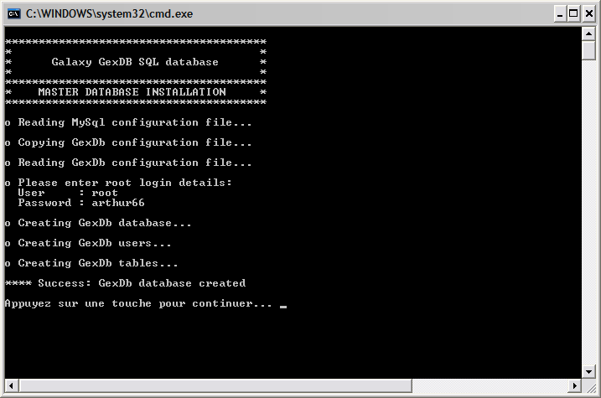
Specify the user name & password of a user who as the privileges of creating a database (usually the root user).

The Galaxy database GexDB is now installed. If this was a master server installation, the master server is running and ready to use replication.

Slave server installation

- Copy all files from the directory <Examinator installation path>/mysql/install to the directory <MySQL installation path>/bin.
- Edit the file <MySQL installation path>/bin/gexdb_mysql_install.ini
This file contains most configuration options for the GexDB database.
We assume the <master-host> designates the master server and <slave-host> the slave server
When performing the setup of the slave server, edit the gexdb_mysql_install.ini file as detailed below:
[InstallOptions]
GexCreateDbOnly=1 | 1: Only create the GexDB database  0: Create the GexDB database, as well as optional tasks (master/slave configuration, purge task configuration, backup task configuration)
[GexDbConfiguration] | Section for configuration settings
GexServerStatus=slave | master: means this is the master server (or a single server)  slave: means this is the slave server (used for replication)
GexServerId=2 | Server ID  Number to range between 1 and 100  1 is reserved for the master  2-100 can be used for any slave  Note : this ID is internally used during replication
GexDataBaseName=gexdb | Galaxy GexDB database name
GexAdminName=gexdb | Administrator of the GexDB
GexAdminPwd=gexadmin | Administrator password
GexUserName=gexdb_user | Read-only user for GexDB
GexUserPwd=gexuser | Read-only user password
GexReplicationName=gexdb_rep | User dedicated to replication
GexReplicationPwd=gexreplication | Password of replication user
GexBinLogName=gexdb-bin-log | Root name used when building bin-log files (used in replication and incremental backups).
GexMasterHost=master-host | Computer name (master server)
# host id for replication
GexSlaveHost=slave-host | Computer name (slave server)
# directory for backup
GexBackupDir="D:/Archives" | Backup folder used by master server for backup storage purpose
[TaskConfiguration] | Section for purge task
GexPurgeSplitlotSamplesAfterNbDays=30 | Maximum number of days to keep data samples (test results and run binning).
GexPurgeSplitlotStatsAfterNbDays=180 | Maximum number of days to hold statistics
GexPurgeSpitlotEntryAfterNbDays=360 | Maximum of days to hold split-lot info
GexPurgeHour=00:00 | Time of day to launch the purge task
GexPurgeEvery=Su | Day of the week to launch the purge  M : Monday  T : Tuesday  W : Wednesday  Th : Thursday  F : Friday  S : Saturday  Su : Sunday  or  1-31 for a given day of the month
 | Setup incremental backup
GexBackupIncrementalHour=00:00
GexBackupIncrementalEvery=M
GexBackupTotalHour=00:00 | Setup full backup
GexBackupTotalEvery=1
Gex CheckAndRepairHour=03 :00
Gex CheckAndRepairEvery=Su

- Execute the installation script <MySQL installation path>/bin/gexdb_mysql_install.bat and follow the displayed instructions:
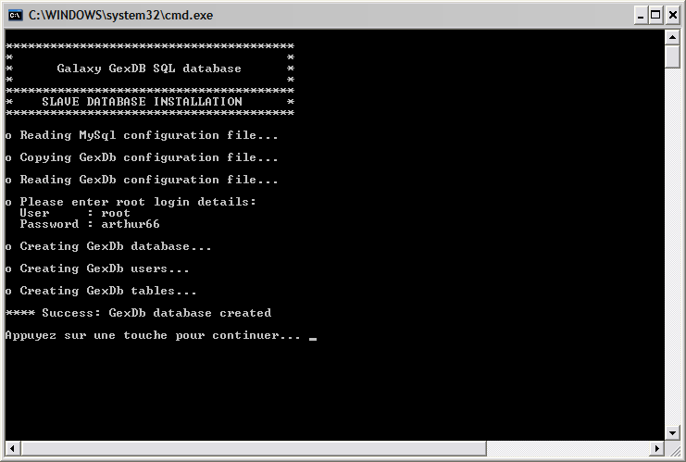
Specify the user name & password of a user who as the privileges of creating a database (usually the root user).

The Galaxy database GexDB is now installed. The slave server is running and ready to use replication.

